Irakli iakashvili
Lab 1.

Cryptography Lab1
Task 1:
Given cyphertext: Hvs Eiwqy Pfckb Tcl Xiadg Cjsf Hvs Zonm Rcu
I did brute force operation on the string and finally got the plaintext:
The Quick Brown Fox Jumps Over The Lazy Dog
Python code
def caesar_decrypt(text, shift):
result = ""
for char in text:
if char.isupper():
result += chr((ord(char) - ord('A') - shift) % 26 + ord('A'))
elif char.islower():
result += chr((ord(char) - ord('a') - shift) % 26 + ord('a'))
else:
result += char
return result

ciphertext = "Hvs Eiwqy Pfckb Tcl Xiadg Cjsf Hvs Zonm Rcu."

# Brute-force all possible shifts
for shift in range(26):
decrypted = caesar_decrypt(ciphertext, shift)
print(f"Shift {shift}: {decrypted}")

Output
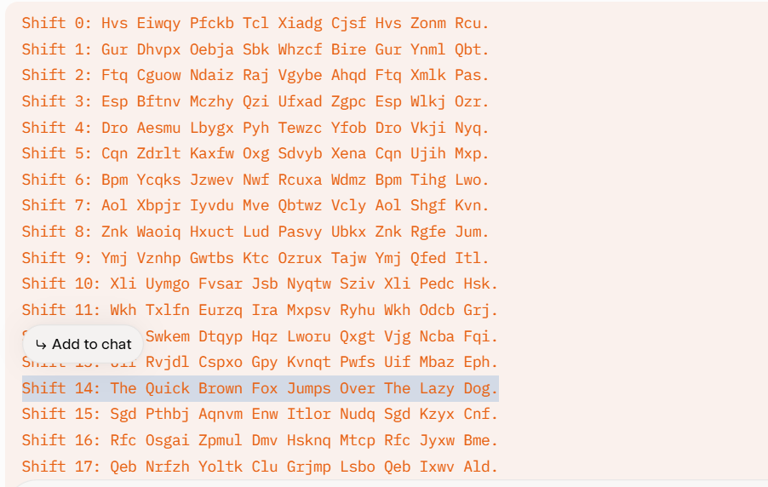

Disscusion
The Caesar cipher is a substitution cipher where each letter is shifted by a fixed number of positions in the alphabet. Its insecurity stems from several fundamental weaknesses:
- Limited Key Space:
  - The Caesar cipher has only 26 possible keys (shifts of 0 to 25 in the English alphabet). This small key space allows an attacker to perform a brute-force attack by trying all possible shifts in seconds, as demonstrated in the provided Python code that decrypted the ciphertext by testing all shifts.
- Vulnerability to Frequency Analysis:
  - English text has predictable letter frequencies (e.g., 'E' ~12.7%, 'T' ~9.1%). In a Caesar cipher, the frequency distribution of letters remains the same, just shifted. By analyzing the frequency of letters in the ciphertext and matching them to expected English frequencies, an attacker can deduce the shift. For example, if 'I' is the most frequent letter in the ciphertext, it likely corresponds to 'E' shifted by 4 positions.
- Preservation of Language Structure:
  - The cipher preserves word lengths, punctuation, and spaces, making it easier to identify common words (e.g., "the" or "and") and infer the shift. In the given ciphertext, "Hvs" (decrypted as "The") and other short words provided clues to the structure.
- No Key Secrecy or Complexity:
  - The key is a single integer, easily guessed or shared. Unlike modern ciphers that use complex keys and mathematical operations, the Caesar cipher lacks computational hardness.
- Susceptibility to Known-Plaintext Attacks:
  - If an attacker knows even a small portion of the plaintext (e.g., a common phrase like "The"), they can immediately determine the shift by comparing it to the ciphertext.
For the provided ciphertext ("Hvs Eiwqy Pfckb Tcl Xiadg Cjsf Hvs Zonm Rcu"), brute-forcing revealed the plaintext "The Quick Brown Fox Jumps Over The Lazy Dog" with a shift of 14. This process took minimal effort, highlighting the cipher’s vulnerability.
.

Task 2:
This is a classic Caesar Cipher decryption challenge. Since the message is short (6 letters), a brute-force attack (trying all 25 possible shifts) quickly reveals the plaintext.
The decrypted word is RESCUE.

Decryption Analysis

1. Brute-Force Attack
We perform a decryption shift (P=C−k(mod26)) for all possible keys k:
- Ciphertext: mznxpz
Key (Shift) | Plaintext | Status
k=1 to k=20 | (Various unreadable combinations) | ❌
k=21 | RESCUE | ✅ SUCCESS
k=22 to k=25 | (Various unreadable combinations) | ❌

2. Verification
The plaintext RESCUE is a coherent English word, matching the requirement that the result is an anagram (or the word Secure) of the passphrase.
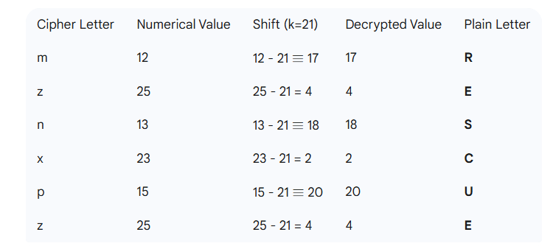

The last step of the task is to XOR. In order to deal with base64 and xor operations, I’ visited the following site: cyberchef.
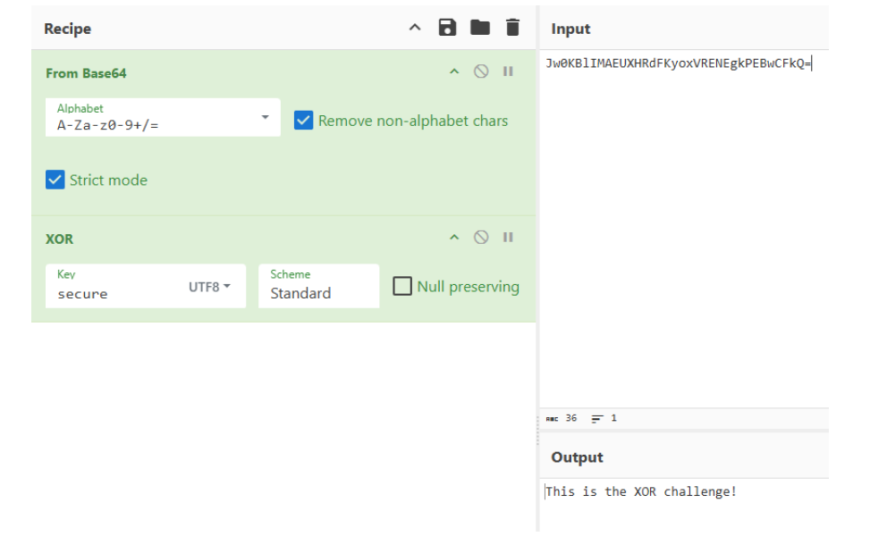
the message is: This is the XOR challenge!

